Computer Programming  
Lab Tasks



Department of Computer Science - BUIC

Name: Saad Ahmad

Enrollment Number: 01-134222-130

**Exercises/Lab Journal 8**

**Task 1**

Declare an array of 4 by 5 size of integers and get user input to fill the array values. Then, find the minimum values in the arrays.

**Code:**

#include <iostream>

using namespace std;

int main() {

int arr[4][5];

int i;

int j;

cout << "Enter the values" << endl;

for (i = 0; i < 4; i++) {

for (j = 0; j < 5; j++) {

cin >> arr[i][j];

}

}

int a = arr[0][0];

for (i = 0; i < 4; i++) {

for (j = 0; j < 5; j++) {

if (a > arr[i][j]) {

a = arr[i][j];

}

}

}

cout << "The minimum vale in the array is : "<<a;

return 0;

}

**Output:**

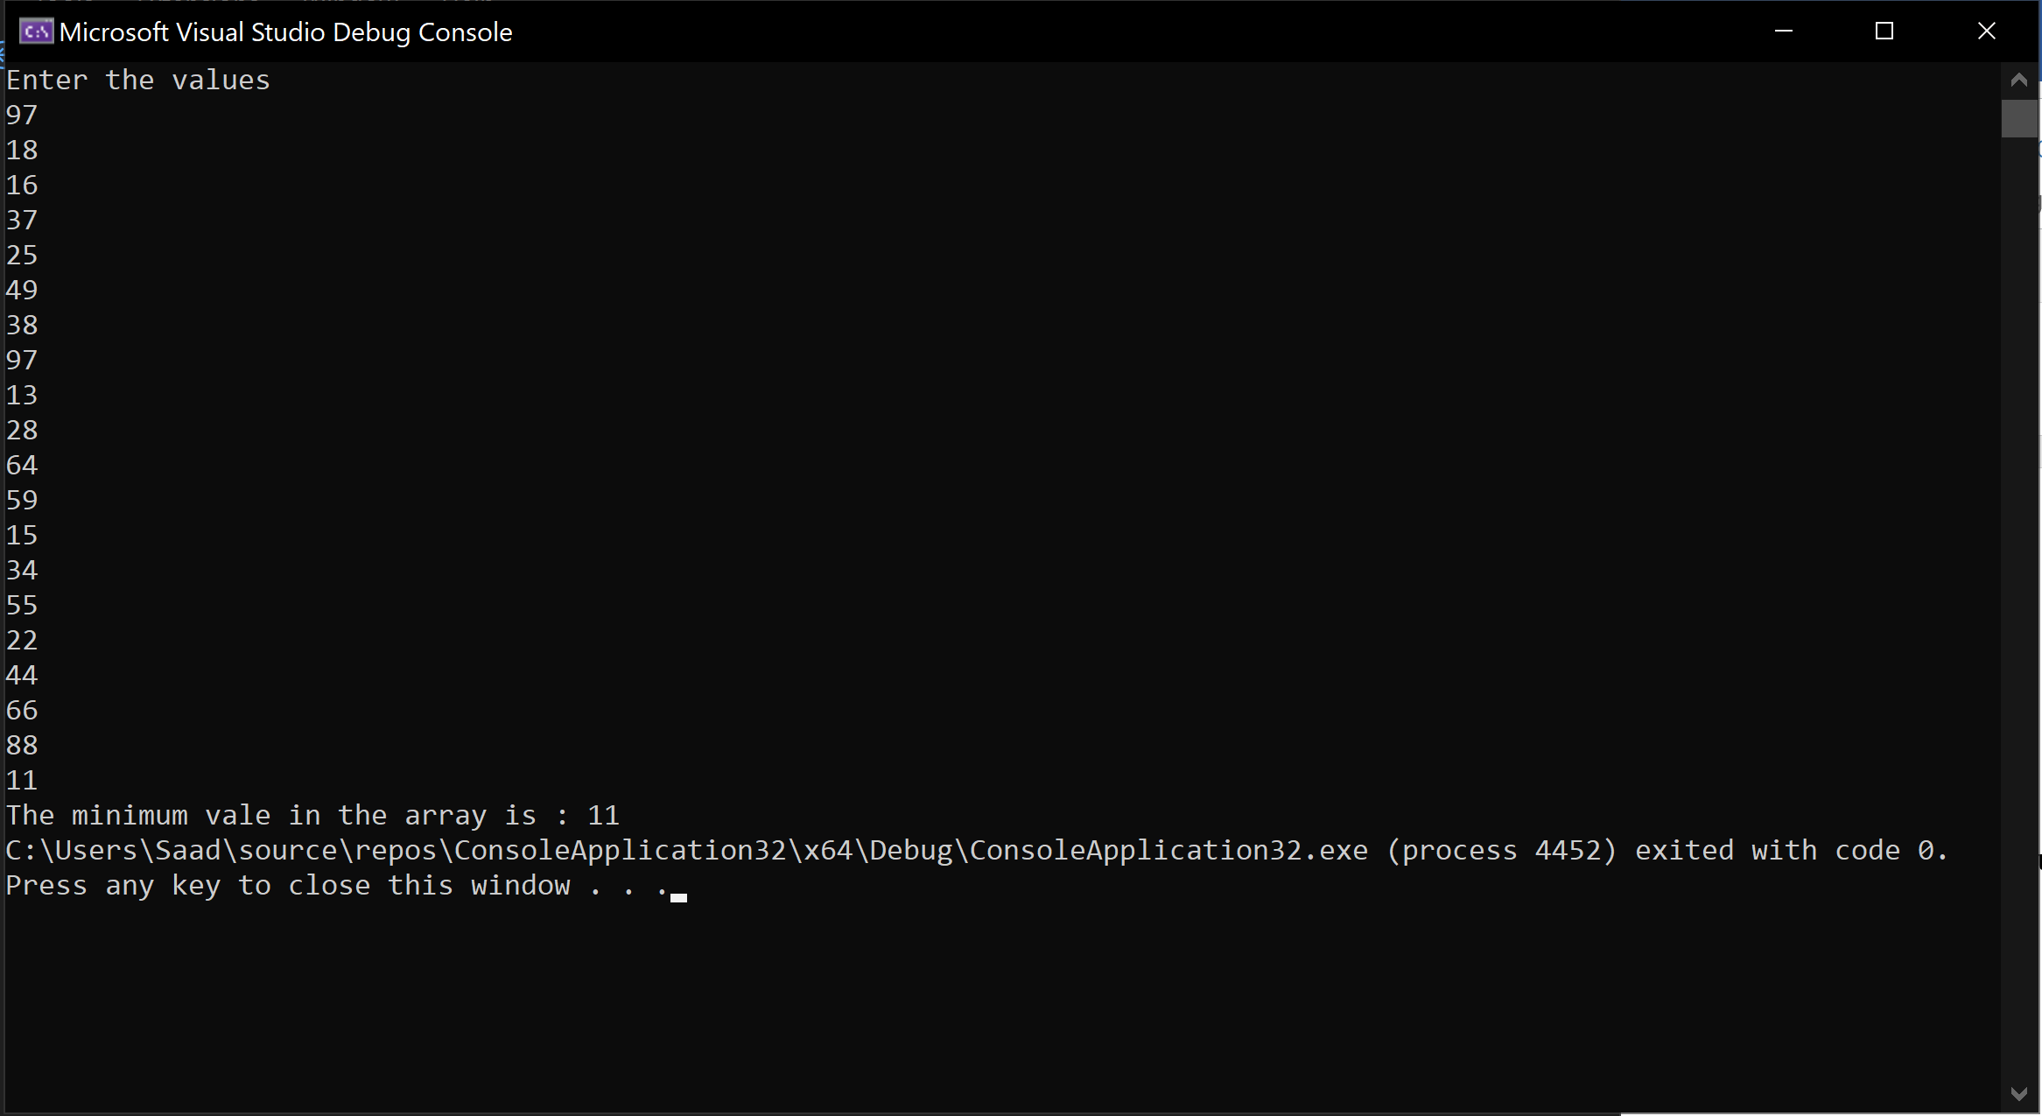

**Task 2**

Write a program to input value in an array of type integer and size 6 by 7. Find out the total number of even and odd values entered in the array.

**Code:**

#include <iostream>

using namespace std;

int main() {

int arr[6][7];

int i;

int j;

int e = 0;

int o = 0;

cout << "Enter the values" << endl;

for (i = 0; i < 6; i++) {

for (j = 0; j < 7; j++) {

cin >> arr[i][j];

}

}

for (i = 0; i < 6; i++) {

for (j = 0; j < 7; j++) {

if (arr[i][j] % 2 == 0) {

e++;

}

else {

o++;

}

}

}

cout << "There are " << e << " even numbers" << " and " << o << " odd numbers";

return 0;

}

**Output:**

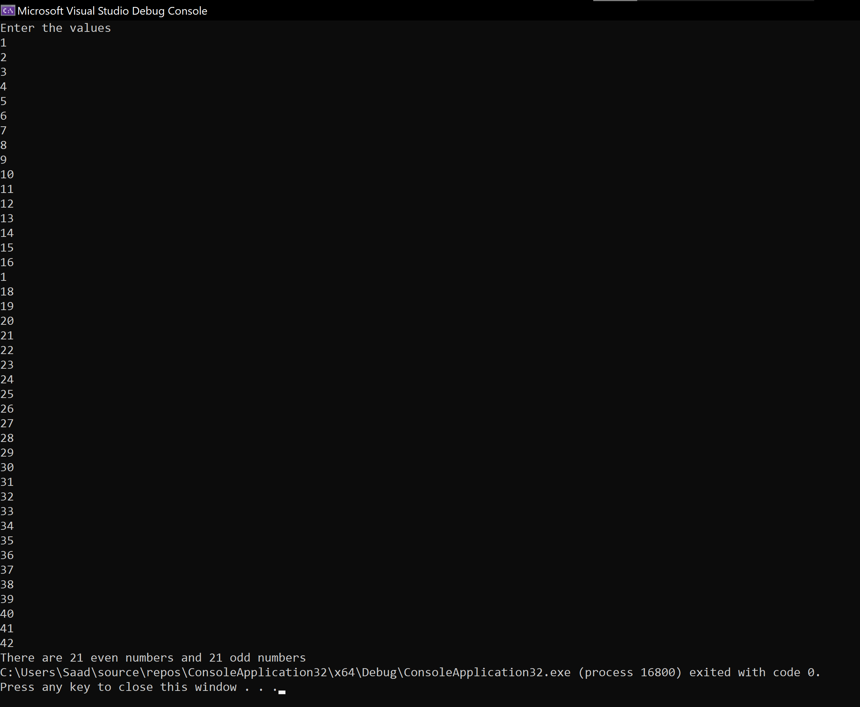

**Task 3**

Write a C++ program that declares an array of size 5 by 20 and assign values to it. Then it asks the user “Enter the number to search in this array”. Then search the number entered by user in the array and display the index on which it was found. (This task is similar to exercise 1.)

**Code:**

#include <iostream>

#include <cstdlib>

using namespace std;

int main() {

int arr[5][20];

int i;

int j;

int search;

srand(10);

for (i = 0; i < 5; i++) {

for (j = 0; j < 20; j++) {

arr[i][j] = rand() % 100;

}

}

cout << "Enter the number to search in this array : ";

cin >> search;

int a = 0;

for (i = 0; i < 5; i++) {

for (j = 0; j < 20; j++) {

if (arr[i][j] == search) {

cout << search << " is found at row " << i << " and column " << j << endl;

a++;

}

}

}

if (a == 0) {

cout << "This number is not present in the array" << endl;

}

return 0;

}

**Output:**

